**Tax literacy improvement through NPWP and tax regulation socialization for MSMEs in Bumi Jaya village**

**Rahmatullah Alfikri** 1* **Audina Rahmi** 2 **Rahmi Nadiar** 3 **Annisa Tri Hidhayati** 4

1,2,3,4 Tanah Laut State Polytechnic, Tanah Laut, 70815, South Kalimantan, Indonesia

**Email**

[rahmatullah@politala.ac.id](mailto:rahmatullah@politala.ac.id) *, [audina@politala.ac.id](mailto:audina@politala.ac.id) , [rahmi@politala.ac.id](mailto:rahmi@politala.ac.id) , [annisatri@politala.ac.id](mailto:annisatri@politala.ac.id)

**Received:** Month, Date, Year (Required) **Revised:**  **Accepted:**

**Abstract**

Tax knowledge is an essential aspect, particularly for small and medium enterprises (SMEs). The socialization of the Taxpayer Identification Number (known as NPWP) literacy is a crucial step in supporting the growth of SMEs in Bumi Jaya Village, Tanah Laut. This community service aims to enhance the understanding of SMEs regarding the importance of the NPWP in business management and tax obligations, as well as the online registration process. The method used is a participatory approach, involving local stakeholders such as the village governance and the SMEs community. The socialization results indicate that SMEs comprehend the process of online NPWP registration. Based on the implementation of this community service, it can be concluded that the program successfully increased tax literacy among SMEs, particularly regarding the understanding of NPWP, its functions, and registration procedures. This success highlights that targeted tax education can positively impact public awareness of tax obligations. SMEs now have a better understanding of the importance of NPWP for business operations, which is expected to encourage greater tax compliance and support structured business growth. However, an active role from the Tax Service Office is still needed to intensively disseminate information, especially considering ongoing changes in tax regulations. Future socialization efforts should also cover aspects such as tax calculation, annual tax return (SPT) reporting, and available tax facilities for SMEs, aiming for improved compliance and contribution to national economic development.

**Keywords:** NPWP, tax regulation, socialization

**DOI :**

**p-ISSN :**

**e-ISSN :**

**ⓒ Copyright: BDJ Action : Breakthrough Development Journal in Advancing Communities the Innovation & Outreach Network (2025)**

**This is an Open Access article distributed under the terms of the Creative Commons Attribution 4.0 International License. Site Using OJS 3 PKP Optimized.**

1. **Introduction**

Tax is one of the important instruments used by the state to support development and public welfare. As a mandatory contribution from the community, tax plays a strategic role in driving the country's economy. Indonesian tax management is carried out by the Directorate General of Taxes (DJP) which plays a role in collecting state revenues through the taxation system. In this case, the Taxpayer Identification Number (NPWP) is the main element to identify each taxpayer, both individuals and business entities. However, many people still do not understand the importance of NPWP and their tax obligations. The level of taxpayer compliance in Indonesia is still relatively low, especially among individuals and Micro, Small, and Medium Enterprises (MSMEs). Ignorance of the registration procedure, the benefits of having a NPWP, and the consequences of not complying with tax regulations are the main factors in this problem, therefore efforts that can overcome these problems are by increasing knowledge and socialization of NPWP. Maxuel and Primastiwi (2021) stated that socialization is an effort to provide insight and guidance to taxpayers so that they understand everything related to taxation. Through proper socialization, taxpayers can understand the importance of the obligation to pay taxes. The active involvement of taxpayers in tax socialization is expected to increase their understanding of the tax system and their level of compliance. NPWP socialization aims to provide the public with an understanding of the importance of tax compliance and the benefits that can be obtained through a transparent tax system. In addition, socialization also helps the public recognize the registration procedures and other obligations inherent in NPWP ownership.

The importance of NPWP socialization lies not only in the legal aspect, but also in its contribution to economic growth. By having a NPWP, taxpayers can actively participate in national development and obtain various tax facilities, such as tax reductions and easy access to business credit. The involvement of citizens in paying taxes is part of an effort to maintain the country, which can indirectly improve the welfare and progress of the nation (Sari et al., 2023; Sartono, 2023; Sunyoto & Astuti, 2024; Wicaksono & Samiono, 2021).

One way of socialization is by conducting direct face-to-face consultations (Setiawan et al., 2023). Zahara and Viyani (2024) stated that the socialization and introduction of E-Reg NPWP resulted in a significant increase in understanding in registering NPWP online effectively and efficiently. The DIII Accounting Study Program of Tanah Laut State Polytechnic has one vision by carrying out applied research in the field of accounting in a planned, structured, and synergistic manner and organizing community service to empower and utilize local potential as a contribution to advancing the economy, one of its services is by providing increased tax literacy for MSME actors in the form of socialization of NPWP registration in Bumi Jaya Village, Tanah Laut Regency, which is a fostered village of Tanah Laut State Polytechnic.

The implementation of increasing tax literacy through community service activities in the form of NPWP socialization aims to answer problems for MSME actors who based on observations, many still do not understand the rights and obligations in taxation and the procedures for registering NPWP online, therefore this training is carried out to invite MSME actors to register NPWP online and convey the importance of participation in building the country.

Mulyono (2024), the head of Bumi Jaya Village, gave his appreciation for the implementation of fostered village programs such as the 2024 Matching Fund (MF) Funding Program, the Ormawa Membangun Negeri Program initiated by the Student Activity Unit of the Digma Politala Student Press Institute, the Independent Entrepreneurship Program (WMK), and the implementation of the Real Work Lecture (KKN) program for 7th semester students. In addition, there is also devotion in the field of free vehicle service by the Automotive Technology Study Program, tax consultation by the DIII Accounting Study Program, free design by the IT Study Program, health check-up services and new student admission information services. This fostered village program is expected to be the first step towards realizing sustainable development in Tanah Laut Regency, where collaboration between universities and the community is the key to improving the welfare of village communities (Politala, 2024).

1. **Research Design and Method**

This community service activity was carried out at the Bumi Jaya Village Office, Tanah Laut Regency with MSME actors. Community service activities by the team were carried out in two stages, namely:

*Planning stage*

At this stage, direct observation was carried out at the service location to find out the problems experienced by MSME actors in Bumi Jaya Village, Tanah Laut Regency. After conducting observations, the next step was to analyze the problems found during the observation and find solutions to these problems, then the PKM team prepared an activity plan, divided the work, and coordinated with the Head of Bumi Jaya Village.

*Implementation stage*

The second activity in the implementation of this community service program is socialization using an offline discussion method. During the socialization, the team invited participants to ask questions. At this stage, the activities carried out to improve tax literacy are socialization of the importance of NPWP, its benefits, and its objectives. In addition, it also carries out the introduction and creation of NPWP through e-registration and the online registration flow via laptop or cellphone

*Evaluation stage*

At this stage, the evaluation is carried out by providing a post-test by asking questions to UMKM Bumi Jaya Village, Tanah Laut Regency regarding the implementation of NPWP socialization such as the importance of NPWP and how to register NPWP online via laptop or cellphone. This is shown so that UMKM actors really understand NPWP registration to tax regulations regarding UMKM.

1. **Results and Discussion**

The implementation of tax literacy through the socialization of NPWP registration and tax regulations for UMKM actors in Bumi Jaya Village, Tanah Laut Regency aims to increase understanding of tax regulations for UMKM and the mechanism for making NPWP online. The socialization activity was carried out for 3 hours (10.00-13.00 WITA) on Thursday, October 31, 2024. NPWP socialization began with observations of problems and their solutions, this was done so that the socialization provided could run smoothly and be easily understood by UMKM actors. The main problem is that UMKM actors in Bumi Jaya Village do not understand how to register for NPWP online and other tax problems related to UMKM. When viewed from its benefits for UMKM, NPWP is useful as a taxpayer identity that provides many benefits both for tax administration purposes or for administrative matters outside of taxation. In addition, NPWP functions (PII, 2019) as follows: 1) as a unique code that is always used in every tax matter that makes your tax data will not be exchanged with other taxpayers; 2) what happens if the tax costs you pay are overpaid? Surely you hope that the money can be returned, right? Simply put, this is what is called tax restitution. To take care of the restitution process, the main requirement is to show the NPWP; and, 3) there is a difference in the amount of tax rates for those who have NPWP and those who do not have NPWP. For example, in the type of PPh article 21 tax. If you do not have a NPWP, the tax rate imposed is 20% higher than taxpayers who have NPWP.

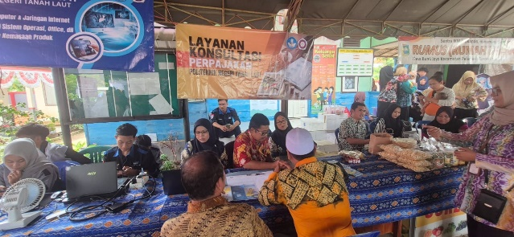

**Figure 1. NPWP Literacy Socialization Activities**

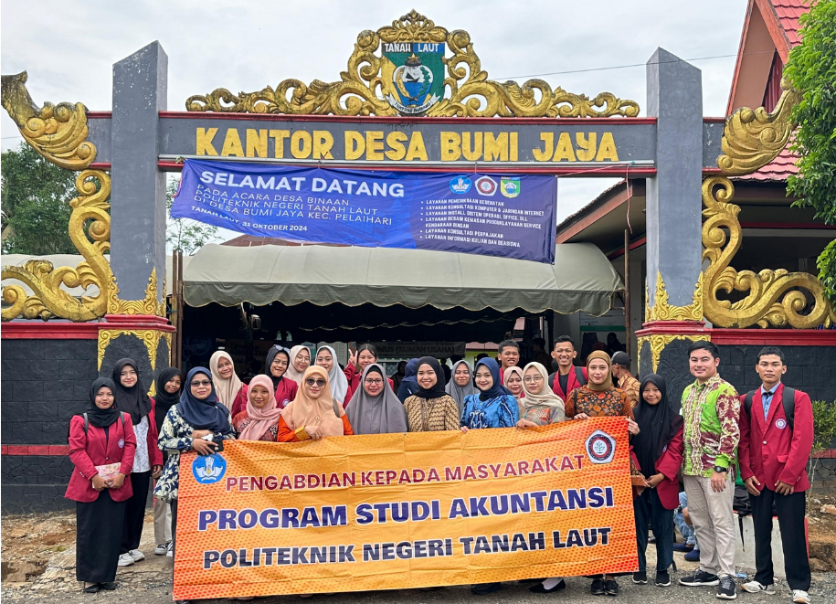

**Figure 2. Group Photo of PKM Activities in Front of Bumi Jaya Village Office**

The next stage is making NPWP online which is carried out by UMKM Bumi Jaya village. Each UMKM actor uses a cellphone/smartphone to create an online NPWP by completing the specified requirements (IKPI, 2024), namely: 1) photocopy of the deed of establishment or document of establishment and amendments for domestic corporate taxpayers, or a letter of appointment from the head office for permanent business entities; 2) photocopy of the Taxpayer Identification Number Card of one of the administrators, or photocopy of passport and certificate of residence from a Regional Government Official at least the Village Head or Village Head in the case where the person in charge is a Foreign Citizen; and, 3) photocopy of business and/or activity permit documents issued by the authorized agency or a certificate of place of business activity from a Regional Government Official at least the Village Head or Village Head or an electricity bill from the Electricity Company/proof of electricity payment.

After the equipment is complete, the UMKM actors of Bumi Jaya Village register online. This socialization begins by opening the website page <https://ereg.pajak.go.id/> , after which each participant carries out e-registration and registers by entering an email that functions as account activation. Participants are required to register data and fill out an online form and register. The creation of this NPWP is also filled with socialization of tax regulations. In general, the procedure for creating a NPWP is one of the requirements to become a taxpayer's identity card in carrying out tax rights and obligations. Creating a NPWP is very important to have as a taxpayer, because in reality there are still not many taxpayers who do not register themselves to obtain the NPWP due to the taxpayer's ignorance and lack of understanding of the procedures for registering themselves to obtain a Taxpayer Identification Number (NPWP). Mardiasmo (2016) stated that NPWP has a very important role in increasing taxpayer compliance. NPWP can be a means for the government to supervise and control the fulfillment of tax obligations.

The final stage, namely the evaluation of the implementation of NPWP socialization by providing direct questions to MSME actors regarding what NPWP is, the function of NPWP, and the mechanism for online NPWP registration. All MSME actors totaling 1,000 people were able to answer and understand the questions given. In addition, to improve tax literacy, this service allows Bumi Jaya Village to consult directly with the Tanah Laut State Polytechnic.

1. **Conclusions**

Based on the implementation of the community service activities, it can be concluded that this program has succeeded in increasing tax literacy among UMKM actors in Bumi Jaya Village, especially in terms of understanding NPWP, its functions, and how to register online. This success shows that targeted tax education can have a positive impact on the public's understanding of their tax obligations. UMKM actors now have better knowledge about the importance of NPWP as a taxpayer identity and its benefits in running their businesses. This understanding is expected to encourage higher tax compliance and help the development of their businesses legally and in a structured manner. However, an active role is still needed from the Tax Service Office to conduct more intensive socialization to the public, especially considering the changes in tax regulations issued by the government. Continuous efforts to provide information and assistance to UMKM are very important to ensure better tax compliance in the future. The socialization carried out should not only be limited to NPWP registration, but also include other aspects of taxation such as tax calculations, SPT reporting, and various tax facilities that can be utilized by UMKM. With a comprehensive understanding, it is hoped that MSMEs can carry out their tax obligations better and contribute to national economic development through timely and appropriate tax payments.

**Reference**

**Serial/journal article (online with DOI):**

IKPI. (2024). *Ini Cara Membuat NPWP Secara Online!* Ikatan Konsultan Pajak Indonesia. <https://ikpi.or.id/ini-cara-membuat-npwp-secara-online/>

Mardiasmo, M. (2016). *PERPAJAKAN–Edisi Terbaru*. Penerbit Andi: Yogyakarta.

Maxuel, A., & Primastiwi, A. (2021). Pengaruh sosialisasi perpajakan dan sanksi perpajakan terhadap kepatuhan wajib pajak UMKM e-commerce. *Jurnal Riset Manajemen Dan Bisnis*, *16*(1), 21-29. Retrieved from <https://e-journalfb.ukdw.ac.id/index.php/jrmb/article/view/76>

PII. (2019). *Fungsi NPWP dan Cara Membuatnya*. Indonesia.go.id. <https://indonesia.go.id/kategori/keuangan/375/fungsi-npwp-dan-cara-membuatnya>

Politala, H. (2024). *Politala Wujudkan Desa Binaan, Sinergi Bersama Membangun Desa Bumi Jaya Di Kecamatan Pelaihari*. Berita Politala. <https://politala.ac.id/politala-wujudkan-desa-binaan-sinergi-bersama-membangun-desa-bumi-jaya-di-kecamatan-pelaihari/>

Sari, E. W., Trisnasari, W. D., & Febriani, A. N. (2023). Membangun budaya sadar pajak pada generasi z. *Madaniya*, *4*(1), 304-310. <https://doi.org/10.53696/27214834.391>

Sartono, S. (2023). Perkembangan hukum perpajakan di indonesia. *Journal on Education*, *5*(3), 8937-8946. Retrieved from <http://repo.jayabaya.ac.id/3100/>

Setiawan, W. A., Syahadat, A. M., Ramdhani, A., Putri, A. R., Adzani, M. R., Anjelica, S., & Wicaksono, Y. S. (2023). Pelatihan pembuatan NPWP dan NIB secara online untuk mendukung legalitas usaha masyarakat. *Buguh: Jurnal Pengabdian Kepada Masyarakat*, *3*(2), 170-184. <https://doi.org/10.23960/buguh.v3n2.1356>

Sunyoto, D., & Astuti, A. Y. (2024). Menuju Masyarakat yang Sadar Pajak: Strategi Efektif dalam Program Pengabdian. *J-MAS: Jurnal Pengabdian Masyarakat*, *2*(5), 909-912. Retrieved from <https://melatijournal.com/index.php/jmas/article/view/523>

Zahara, I., & Viyani, A. O. (2024). Bela negara perspektif pajak: sosialisasi pentingnya NPWP dan pengenalan E-Reg NPWP pada tim penggerak PKK di Kalurahan Ngargosari. *Jurnal Pengabdian kepada Masyarakat Nusantara*, *5*(3), 3566-3572. <https://doi.org/10.55338/jpkmn.v5i3.3589>

**Conference paper (online):**

Wicaksono, D., & Samiono, B. E. (2021). Pengenalan pencatatan dan penggunaan program keuangan pada UMKM kuliner di Ulujami. *Prosiding Konferensi Nasional Pengabdian Kepada Masyarakat dan Corporate Social Responsibility (PKM-CSR)*, *4*, 1221-1226. <https://doi.org/10.37695/pkmcsr.v4i0.1200>