**Training on Classroom Action Research (CAR) for teachers at SMPN 5 Marabahan, Barito Kuala Regency**

**Abul Hasan Asy’ari** 1* **Rofinus Leki** 2 **Rahmat Hilmi** 3 **Siti Paujiah** 4 **Jaya Bahwiyanti** 5

1,2,3,4,5 Pancasetia College of Economics, Banjarmasin, 70248, Kalimantan Selatan, Indonesia

**Email**

[abulhasan.asyari96@gmail.com](mailto:abulhasan.asyari96@gmail.com) *, [yohanrl976@gmail.com](mailto:yohanrl976@gmail.com) , [rahil.hilmi@gmail.com](mailto:rahil.hilmi@gmail.com), [jiahmanis8@gmail.com](mailto:jiahmanis8@gmail.com) , [jayabahwiyanti@gmail.com](mailto:jayabahwiyanti@gmail.com)

**Received:** Month, Date, Year (Required) **Revised:**  **Accepted:**

**Abstract**

The goal of this community service is for teachers at SMPN 5 Marabahan to: 1) understand the stages of Classroom Action Research (CAR); and 2) be motivated and capable of conducting Classroom Action Research. CAR training at SMPN 5 Marabahan was conducted through a lecture method using laptops and LCD projectors to explain key components of CAR, including problem formulation, objectives, benefits, theoretical foundation, and research methods, with opportunities for teacher interaction. Preparations included obtaining permission from relevant institutions, preparing material summaries, and setting up equipment such as LCDs and sound systems. During the training, the teachers showed great enthusiasm, which was evident from the number of questions asked and the smooth flow of discussions. After the presentation of the material and examples of CAR, it became clear that the teachers had begun to understand how to write CAR and the procedures for submitting research to scientific journals. Many teachers, particularly those at rank III/a, expressed their eagerness to start writing CAR, as they now understood the techniques and requirements for promotion. It is recommended that schools with teachers who have limited or no experience in writing scientific papers or research articles consider enrolling them in more comprehensive CAR writing training held by experienced institutions, as the current training was limited by time and therefore not yet optimal. Overall, this activity provided a strong foundation for developing teachers' research skills and fostering a culture of scientific writing at the school.

**Keywords:** training, Classroom Action Research (CAR), teacher

**DOI :**

**p-ISSN :**

**e-ISSN :**

**ⓒ Copyright: BDJ Action : Breakthrough Development Journal in Advancing Communities the Innovation & Outreach Network (2025)**

**This is an Open Access article distributed under the terms of the Creative Commons Attribution 4.0 International License. Site Using OJS 3 PKP Optimized.**

1. **Introduction**

One form of professional development for teachers is the enhancement of their ability to produce scientific written works. This ability can be easily seen through the publications of teachers in various media, especially scientific journals. Writing such scientific works is believed to enhance teachers' professionalism while simultaneously improving the quality of the teaching they deliver.

Currently, teacher promotion regulations are based on the Ministry of Administrative and Bureaucratic Reform Regulation Number 16 of 2009 regarding credit points for positions and the joint regulations of the Minister of National Education and the Head of the State Personnel Agency Number 3/V/PB/2010 and Number 14 of 2010. These regulations stipulate specific requirements for teachers, focusing on four main components: first, education; second, teaching; third, continuous professional development; and fourth, supporting components. The goal of these professional development activities is to improve and solidify teachers' professionalism, elevate their image, and ensure their dignity and pride in holding the teaching profession.

As part of the promotion process, teachers are required to produce scientific publications or innovative works, which can include scientific papers, teaching aids, or technological and artistic works. One way to create such works is through research. There are various types of research that teachers can undertake, including descriptive research, impact studies, surveys, case studies, and action research. Among these, Classroom Action Research (CAR) is considered the most suitable for teachers.

Classroom Action Research (CAR) is a form of research focused on applying actions to improve quality or resolve issues within a specific group of subjects. The effectiveness of these actions is then observed and analyzed, leading to further steps for refinement or adjustment to improve results. According to Arikunto (2006), CAR follows distinct stages, including planning, action, observation, analysis, and reflection. These stages form the basis for teachers to carry out CAR effectively.

Kemmis and Taggart (1988) explain that action research is a form of self-reflective study undertaken by participants in social situations (including education) to improve their own practices. In the context of education, this research develops into Classroom Action Research, which focuses on improving the quality of teaching. CAR involves the teacher actively identifying problems in the classroom and working collaboratively with colleagues to address these issues. By participating in CAR, teachers can enhance their teaching practices and ultimately improve student outcomes.

However, discussions with teachers at SMPN 5 Marabahan revealed that many teachers still lack understanding of Classroom Action Research, despite its importance in improving teaching quality. By gaining an understanding of CAR, teachers can better identify and resolve teaching problems within their classrooms. This, in turn, enhances the quality of learning, which leads to improved student engagement and better learning outcomes. The main objective of CAR is to improve both the activity and learning results of students.

Thus, it is essential to provide training for the teachers of SMPN 5 Marabahan on the procedures for conducting Classroom Action Research. This training aims to ensure that teachers are well-equipped to implement CAR in their classrooms and enhance the overall learning environment.

The goal of this training is for teachers at SMPN 5 Marabahan to: 1) understand the stages of Classroom Action Research; and, 2) be motivated and capable of conducting Classroom Action Research.

The benefit of this training is that teachers will be able to implement CAR, which plays a vital role in improving their professional, pedagogical, personal, and social competencies. This will boost teachers' confidence and enable them to design necessary changes in the school’s learning processes. Enhancing the teachers' professional competencies will also facilitate efforts to improve their welfare by increasing their credit points, which is required for promotion.

1. **Research Design and Method**

The topic of the community service is Classroom Action Research (CAR). Considering the need for teachers to be promoted is to conduct research or write scientific papers and the research theme is required to be CAR. Based on the previous description, the target audience in this community service activity is teachers of SMPN 5 Marabahan

The lecture method is carried out by visiting SMPN 5 Marabahan to provide classroom action research (CAR) training. This lecture activity was carried out considering that many teachers have difficulty understanding class action research both in making proposals and in implementing them. On the occasion of the community service, the presentation used laptop and LCD displays and explained one by one about CAR, how to make a problem background, how to make a problem formulation, how to make research objectives and benefits, how to make a theoretical basis, and how to make a research method. During the lecture, it was targeted that all teachers at SMPN 5 Marabahan would participate in the activity. In this activity, the opportunity was given to ask the teachers if there was still something that was not understood. The presenter acted as a facilitator for the teachers.

Before carrying out the classroom action research training, the preparations were: 1) asking permission from the relevant parties, namely the campus and school where the implementation was carried out; 2) preparing a summary of the material to be distributed to participants; 3) preparing equipment used for socialization activities such as LCD and sound systems.

1. **Results and Discussion**

This community service event was held on December 22, 2021, at the SMPN 5 Marabahan hall with the theme "Writing Classroom Action Research Proposals for SMPN 5 Marabahan Teachers in 2021". The event was opened by the principal by giving a speech for ± 15 minutes, then the activities began according to the planned event. The event was arranged in three sessions. The first session was a presentation of material by the presenter, the second session was a question-and-answer session regarding PTK material, and the third session was a discussion and analysis of PTK research examples by dividing participants into several groups, then the training participants were given the task of making a draft of the research title and compiling a PTK proposal. Furthermore, the participants were explained examples of PTK that had been entered into scientific journals and the methods and procedures for writing were explained according to the writing rules.

After the training, it is hoped that teachers will be able to conduct PTK research which can then be included in scientific journals. It is hoped that after the training, teachers will be more motivated to conduct research, especially PTK, so that they can improve teacher professionalism which can then be used as a proposal for promotion.

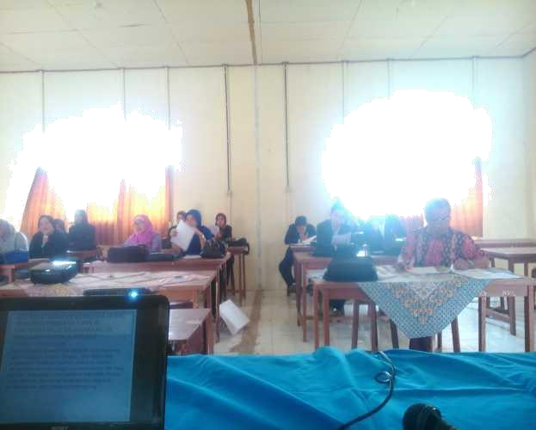

**Figure 1. Implementation of Community Service Activities**

1. **Conclusions**

During the training, the teachers showed great enthusiasm, which was evident from the number of questions asked and the smooth flow of discussions. After the presentation of the material and examples of classroom action research (CAR), it became clear that the teachers had begun to understand how to write CAR and the procedures for submitting research to scientific journals. Many teachers, particularly those at rank III/a, expressed their eagerness to start writing CAR, as they now understood the techniques and requirements for promotion. It is recommended that schools with teachers who have limited or no experience in writing scientific papers or research articles consider enrolling them in CAR writing training held by experienced institutions, as the current training was limited by time and therefore not yet optimal.

**Reference**

**Serial/journal article (online with DOI):**

Arikunto, S., Suhardjono, and Supardi. (2006). Classroom Action Research. Jakarta: Bina Aksara.

Kemmis, S. and McTaggart, R. (1988). *The Action Research Reader*. Victoria: Deakin University Press.

Law of the Republic of Indonesia Number 14 of 2005 concerning Teachers and Lecturers.

Regulation of the Minister of Administrative and Bureaucratic Reform Number 16 of 2009, concerning Functional Positions of Teachers and Their Credit Points.