**Financial report preparation using SIAPIK application:**

**A case study on Siomay Super MSME**

**Dileon Edgar Davis** 1 **Euniqa Natalia Angelica** 2 **Gerald Gregorius Natalino** 3

**Jerryl Zefanya** 4* **Mario Adriano Vincenzo** 5 **Surya Saputra** 6

1,2,3,4,5,6 Atma Jaya Catholic University of Indonesia, South Jakarta, 12930, Jakarta, Indonesia

**Email**

[gerald.202201020084@student.atmajaya.ac.id](mailto:gerald.202201020084@student.atmajaya.ac.id), [jerryl.202201020080@student.atmajaya.ac.id](mailto:jerryl.202201020080@student.atmajaya.ac.id) *

**Received:** Month, Date, Year (Required) **Revised:**  **Accepted:**

**Abstract**

The role of MSMEs is very important in Indonesia; according to data from the Ministry of Cooperatives and SMEs, the contribution of MSMEs to the national GDP is 60.5%. This shows that Indonesian MSMEs have great growth potential, enabling them to make an even greater contribution to the national economy. This community service activity was carried out through two stages, namely the preparation stage and the implementation stage. The results of the findings and discussions are as follows: Preparing good financial reports, such as the statement of financial position, income statement, and cash flow statement, is essential for better corporate governance. The SI APIK application proved effective in simplifying the process of recording and preparing financial reports. Increased knowledge and skills provided direct benefits to MSME owners while also broadening participants' understanding of the importance of accounting and financial reporting in business management. Strengthening the relationship between science and society reflects a good synergy between the world of education and practice in the field, allowing students to interact directly with the community. The community service activity conducted at the Siomay Super MSME successfully achieved its stated goals. Through training and the use of the SI APIK application, business owners gained a better understanding of how to prepare systematic and accurate financial reports. This activity demonstrated the usefulness of the SI APIK application in facilitating financial management and is expected to positively contribute to the development of MSMEs, serving as a model for future initiatives.

**Keywords:** MSMEs, financial statements, SI APIK, siomay, dumpling

**DOI :**

**p-ISSN :**

**e-ISSN :**

**ⓒ Copyright: BDJ Action : Breakthrough Development Journal in Advancing Communities the Innovation & Outreach Network (2025)**

**This is an Open Access article distributed under the terms of the Creative Commons Attribution 4.0 International License. Site Using OJS 3 PKP Optimized.**

1. **Introduction**

MSMEs (Micro, Small and Medium Enterprises) are companies or business entities run by individuals, groups, small businesses, or even households. Indonesia itself as a developing country has MSMEs as the main basis of the community's economic sector. This is done to improve the community's ability to be independent and develop, especially in the economic sector. The development of MSMEs in Indonesia continues to increase in various aspects and qualities. With strong government support for the development of MSME actors, they play an important role in anticipating economic conditions and strengthening the national economy. In this digital era, MSMEs can also take advantage of strategies by tracking consumer shopping styles from offline to online. However, some MSME actors have poor performance because their businesses are not running well and unstable finances can affect business continuity and reduce income. The role of MSMEs is very important in Indonesia, according to data from the Ministry of Cooperatives and SMEs, the contribution of MSMEs to national GDP is 60.5%. This shows that Indonesian MSMEs have great growth potential so that they are able to make a greater contribution to the Indonesian economy. The Government of the Republic of Indonesia has supported MSMEs by providing People's Business Credit (KUR). Based on existing data, KUR growth was IDR 178.07 trillion or 16.25% in 2020 and increased by IDR 192.59 trillion in 2021. Most MSMEs in Indonesia are family businesses. Based on data from the Ministry of Cooperatives and Small and Medium Enterprises, there were 65.4 million MSMEs in Indonesia in 2019, with a total of 65.4 million business units capable of absorbing a workforce of 123.3 thousand people. Currently, MSMEs have their own standards in preparing financial reports, especially the Financial Accounting Standards for Micro, Small and Medium Enterprises (SAK EMKM). The issuance of accounting standards for MSMEs greatly assists MSMEs in recording or preparing financial reports, but not all MSMEs can use these standards in preparing financial reports due to limitations in understanding how to use SAK EMKM. The UNIKA Atma Jaya Jakarta Financial Accounting Practice Course provides understanding and facilities to help present, prepare and implement financial reports. Financial reports are important but rarely used by MSMEs due to lack of knowledge about accounting and financial reporting. There are also community service activities to support financial reporting that can help MSMEs in calculating their performance.

Financial statements are a summary of financial information presented systematically and structured, reflecting the results of operations, financial position, and cash flow of an entity (company) in a certain period. Financial statements aim to provide relevant, accurate, and timely information about the performance, position, and financial flow of an entity, which can be used for decision making by various interested parties. Most people use financial statements to make economic decisions and also show responsibility for the resources provided. Financial statements also present information about assets, liabilities, owner's equity, income and expenses, including profit and loss, contributions and distributions to owners as well as owners and cash flow. Financial statements contain the following contents: financial position statement, income statement, capital change statement, cash flow statement, and notes to financial statements.

SI APIK is a business financial recording application released by Bank Indonesia as a form of support for micro, small, and medium enterprises (MSMEs). Many MSMEs still ignore business financial recording, for this reason BI wants to encourage more MSMEs to record business finances more easily through a digital platform based on the SI APIK application. In the SI APIK application there are several features, namely the receipt feature consisting of, receipt of funds from business activities, receipt of funds from lenders, and receipt of funds from owners, then there is also an expenditure feature consisting of, expenditure of funds for business activities, expenditure of funds to lenders, expenditure of funds to owners, and there is a more detailed financial report recording feature.

Based on the previous explanation, the formulation of the problem of community service are: 1) What is the role of participants in carrying out this activity? 2) How to use the SI APIK application in preparing Financial Reports at MSME Siomay Super? 3) Does the preparation of Financial Reports have an influence on the development of MSME? 4) How can this activity help UMKM actors in preparing Financial Reports?

The objectives of this community service activity are: 1) the role of participants in the activity is to help MSME actors in understanding and preparing financial reports; 2) the use of the SI APIK application to facilitate the preparation of financial reports at UMKM Siomay Bang Adi; 3) preparation of Financial Reports can help MSME to develop, as well as provide knowledge about good financial governance; and 4) helping MSME actors in understanding the methods and processes in preparing financial reports and the importance of Financial Reports in a business.

1. **Research Design and Method**

This community service activity is carried out using two methods, so that this activity can achieve the targets or goals that have been set and implemented. The following are the two methods used.

*Preparation stage*

Before entering the next stage, we need to make preparations so that the activity can run smoothly and can be completed properly. The following are the stages of preparation for implementing community service activities that have been carried out: 1) participants in the implementation of the activity are given directions and an overview of how to prepare financial reports; 2) participants in the activity are given directions in using the SI APIK application; and, 3) participants in the implementation of the activity are given the opportunity to determine and choose a place that will be the point of implementation of the activity that will take place

*Implementation stage*

After the preparation process and location selection, the next stage is the implementation of the activity. The implementation process of the activity "Preparation of Financial Reports Using the SI APIK Application in Micro, Small and Medium Enterprises (MSMEs)" has several stages that need to be followed, as follows. First, location selection stage. Participants are free to choose a location to conduct research, but the location must be different from other participants. At this stage, the selection of the location greatly influences the process of running an activity and the preparation of financial reports.

Next, location survey stage. The location survey is carried out by visiting the selected location, at this location survey stage participants also introduce themselves and inform the intent and purpose of the visit and then ask for approval from the siomay dumpling owner. After getting approval, participants can discuss with the siomay dumpling owner to determine the interview and discussion schedule.

Then, interview and discussion stage. After conducting the survey and determining the time for the interview, at this stage the implementation team gathers at the location according to the time agreed upon with the siomay dumpling owner. Then the participants introduce themselves once again and after that enter the interview stage, in this interview process the participants collect the required data, and conduct a quest Implementation Stage ion and answer session with the siomay dumpling owner regarding the process and how to make siomay dumpling.

Last, financial report preparation stage. At this stage the participants prepare financial reports, before entering this process the participants have asked for permission and obtained permission from the owner of Somay Bang Adi to prepare financial reports using the SI APIK application. The process of preparing this financial report uses data that has been collected during the interview with the siomay dumpling owner, then the participants process the data by compiling the data into a financial report, starting from the financial position report (balance sheet), profit and loss report, and cash flow report using the SI APIK application.

*Activity schedule*

The following is the process of activities that have been carried out to help Siomay Super UMKM: 1) discussions were held with group members to determine the activities and objectives of the investigation; 2) discuss directly with the owner of the siomay so that the interview runs smoothly; 3) carry out a series of activities in the form of data collection that has been explained in detail above in the explanation method section; and, 4) compile the results of community service activities as a final report for the 2024/2025 Odd Semester Mid-Term Exam for the Financial Accounting Practice course at Atma Jaya Catholic University, Jakarta.

1. **Results and Discussion**

In carrying out this activity, our group did not encounter any obstacles so that we completed it smoothly. At first, our team discussed choosing a place and owner of the somay that we would study. When we had discussed it, we decided to choose an MSME operating in the front yard of a housing complex. After conducting research, we realized that the data collection process provided new insights into the aspects needed in running a business. Our group managed to overcome problems and difficulties by using the SI APIK application. Previously, to create a Financial Position Report, Profit and Loss Report, and Cash Flow Report, we had to create tables one by one which were prone to errors. However, with this application, creating tables becomes easier and more practical. When entering the data obtained, SI APIK will automatically compile accounting tables and financial reports complete with the required values. In our opinion, this application can help the team work efficiently and is also useful for MSME business owners to prepare their financial reports. We are also sure that this SI APIK application can reduce the potential for errors in accounting compared to having to write manually.

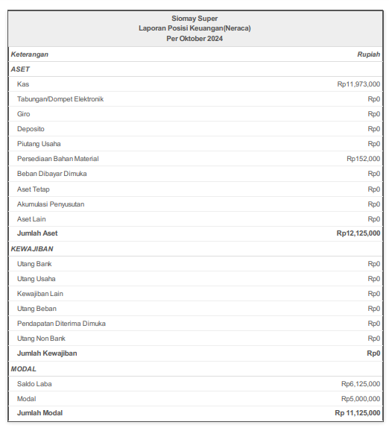

**Figure 1: Statement of Financial Position (Balance Sheet) on October 28, 2024**

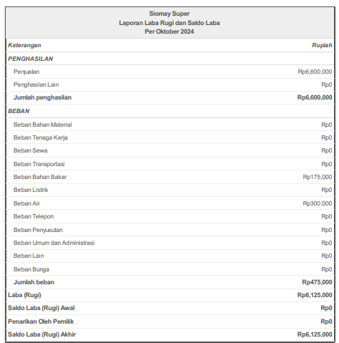

**Figure 2: Income Statement and Retained Earnings as of October 28, 2024**

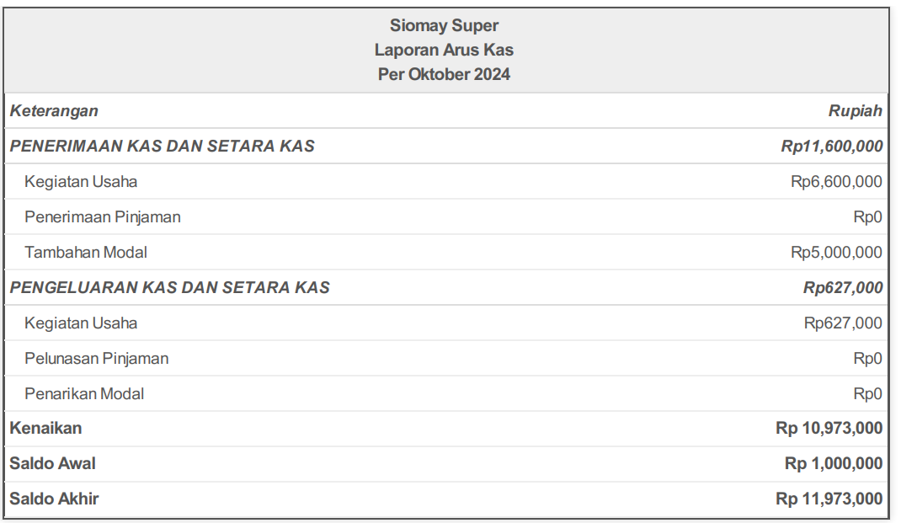

**Figure 3: Cash Flow Statement as of October 28, 2024**

|  |  |
| --- | --- |
|  |  |

**Figure 4. Siomay Super MSME**

1. **Conclusions**

The community service activity conducted at the Somay Super MSME successfully achieved its stated goals. Through the implementation of training sessions and the use of the SI APIK application, business owners gained a better understanding of how to prepare systematic and accurate financial reports. This activity emphasized the importance of financial reporting for effective business governance, demonstrated the usefulness of the SI APIK application in simplifying financial management, enhanced participants' knowledge and skills in accounting practices, and strengthened the synergy between academic institutions and society. It is hoped that this activity will positively contribute to the development of MSMEs and serve as a model for future community service initiatives.

The success of this community service activity would not have been possible without the support and contributions of various parties. We extend our sincere gratitude to Mr. Yanuar Nanok Soenarno, S.E., M.Ak., Lecturer of Atmajaya Semanggi Catholic University for the Financial Accounting Practice course, for his guidance throughout the project. Special thanks are also given to Mr. Adit, owner of Siomay Super MSME in Matraman, East Jakarta, for his valuable cooperation and willingness to provide data through interviews and observations. We also appreciate the assistance of all other parties who have contributed to this activity, whose names cannot be mentioned one by one.

**Reference**

**Serial/journal article (online with DOI):**

Kaihrulid. (2006, 3 Maret). Usaha mikro, kecil, dan menengah. Diakses pada 28, Oktober 2024 dari <https://id.m.wikipedia.org/wiki/Usaha_mikro,_kecil,_dan_menengah>

Pamiliana, Aknes. (2017, 21 Oktober). Pengabdian masyarakat. Diakses 24, Oktober 2024 dari <https://id.m.wikipedia.org/wiki/Pengabdian_masyarakat>

Sayoga, Prasetyo. (2024, 31 Januari). Laporan Keuangan: Pengertian, Jenis, dan Contohnya. Diakses pada 24 Oktober 2024 dari <https://pina.id/artikel/detail/laporan-keuangan-pengertian-jenis-dan-contohnya-mlaym46fxi0>

Sia, Vely. (2024, 3 Januari). Laporan Posisi Keuangan: Pengertian, Jenis, Contoh. Diakses pada 24 Oktober 2024 dari <https://www.jurnal.id/id/blog/pengertian-dan-contoh-laporan-posisi-keuangan/>

Lanin, Ivan. (2006, 8 Maret). Laporan laba rugi. Diakses pada 24 Oktober 2024 dari <https://id.m.wikipedia.org/wiki/Laporan_laba_rugi>