**National insight socialization with South Kalimantan Parliament in Aluan Village, HST Regency**

**Hamdi** 1* **Yondi Caturadina Darnida** 2 **Muhammad Risanta** 3

**Hardika Muhammad Fatih** 4 **Aulia Helmina Putri** 5

1,2,3,4,5 Pancasetia College of Economics, Banjarmasin, 70248, South Kalimantan, Indonesia

**Email**

[primarantau@gmail.com](mailto:primarantau@gmail.com) *, [yondikeisha@gmail.com](mailto:yondikeisha@gmail.com), [santakalsel@gmail.com](mailto:santakalsel@gmail.com),

[hardikamf@gmail.com](mailto:hardikamf@gmail.com), [bjm.hpaulia@gmail.com](mailto:bjm.hpaulia@gmail.com)

**Received:** Month, Date, Year (Required) **Revised:**  **Accepted:**

**Abstract**

This community service focuses on the socialization of national insight (Wawasan Kebangsaan) conducted in collaboration with the Regional House of Representatives (DPRD) of South Kalimantan Province in Aluan Village, Hulu Sungai Tengah Regency. The program aims to strengthen the understanding of national values among local communities and government officials. The initiative is rooted in six key dimensions of national insight: respect for human dignity, collective determination for freedom and unity, love for the homeland, democracy, social solidarity, and the pursuit of a just and prosperous society. The socialization method involves interactive discussions, presentations, and direct engagement with community members to instill these values, fostering a sense of shared national responsibility. The results demonstrate a significant improvement in participants' understanding of these values, with increased awareness of their importance in maintaining national unity and social cohesion. The program has also contributed to enhancing the relationship between local government institutions and the community, emphasizing the role of democracy and mutual cooperation in governance. In conclusion, this community service activity underscores the importance of national insight in shaping a unified, prosperous Indonesia. It highlights the ongoing need for similar initiatives to strengthen national identity and socio-political stability, particularly in rural and remote areas. This approach serves as a valuable model for promoting national insight in local communities, ensuring its continuity in future generations.

**Keywords:** national insight, socialization, Regional House of Representatives (DPRD) of South Kalimantan

**DOI :**

**p-ISSN :**

**e-ISSN :**

**ⓒ Copyright: BDJ Action : Breakthrough Development Journal in Advancing Communities the Innovation & Outreach Network (2025)**

**This is an Open Access article distributed under the terms of the Creative Commons Attribution 4.0 International License. Site Using OJS 3 PKP Optimized.**

1. **Introduction**

National insight, or *wawasan kebangsaan*, reflects the awareness and behavior of citizens in alignment with the ideals and goals of the Indonesian nation, as mandated by the Preamble of the 1945 Constitution (Undang-Undang Dasar 1945). This perspective promotes unity among Indonesia’s diverse ethnic and cultural communities, binding them under shared values of Pancasila and constitutional principles (Sudrajat, 2011). In areas such as South Kalimantan, particularly Hulu Sungai Tengah, it is vital to strengthen this national consciousness to maintain social cohesion and national resilience.

However, recent social changes indicate a declining sense of national responsibility among the youth. This erosion of social sensitivity can weaken the nation's integrity if left unaddressed. The youth must be empowered to understand and internalize the meaning of patriotism, solidarity, and active citizenship. As stated by Winarno (2012), national insight should not only be a theoretical concept but must be actively cultivated through education and community engagement.

The ideological basis of this initiative lies in Pancasila, which is both the ethical and philosophical foundation of Indonesia. It serves as a guideline for moral conduct in socio-cultural, political, and legal life (Kaelan, 2013). In conjunction, the 1945 Constitution (UUD 1945), particularly its Preamble, serves as the constitutional source of national values, articulating the ideals of independence, justice, and unity (Asshiddiqie, 2006).

Through this community service activity, socialization of national insight in Aluan Village is intended to foster a stronger sense of nationalism, civic responsibility, and patriotism among local communities, especially the youth. It is expected that such activities will contribute meaningfully to the cultivation of national character and support the sustainability of the Unitary State of the Republic of Indonesia (NKRI).

1. **Research Design and Method**

The implementation method of this community service activity employed a participatory approach by directly involving local community members at every stage of the program. The activity began with the preparation of relevant materials on national insight (*wawasan kebangsaan*), including core concepts such as the values of Pancasila, the 1945 Constitution (UUD 1945), the spirit of *Bhinneka Tunggal Ika*, and the principles of the Unitary State of the Republic of Indonesia (NKRI). In addition to content preparation, the team also arranged the necessary logistical support, including presentation tools and discussion materials. Participant identification and community condition mapping in Aluan Village, Hulu Sungai Tengah, were conducted to ensure that the delivery of the materials would be effective and contextual. The activity itself involved presentations and briefings through a series of socialization sessions and interactive dialogues aimed at enhancing the participants' understanding and awareness of nationalism. The delivery was designed to be communicative and engaging, encouraging community members to actively participate in discussions and share their perspectives. After the activity, the team compiled a comprehensive report as an academic responsibility and as documentation for future improvements. The program took place at the Aluan Village Office, which served as the central venue for the implementation of this community service initiative.

The schedule of activities for the Community Service program is planned for three (3) days. The schedule includes the following stages: initial preparation, implementation, and report writing, with each stage allocated one day respectively. The report preparation will require several days in total, divided into one day for initial preparation, one day for implementation, and one day for report compilation.

1. **Results and Discussion**

The Preamble of the 1945 Constitution of the Republic of Indonesia (UUD 1945), placed at the forefront of the Constitution, is the foundation where various fundamental norms are proclaimed. It reflects the noble ideals of the Proclamation of Independence on August 17, 1945. Because of its foundational nature, the Preamble is immutable and serves as the legal basis and source of authority for the body of the 1945 Constitution as well as for any future Constitutions of the Republic of Indonesia.

These fundamental norms, representing the noble aspirations of the Indonesian people in the conduct of national and state affairs, can be traced through the four paragraphs of the Preamble of the 1945 Constitution:

***First Paragraph***

“That independence is the right of all nations and therefore, colonialism must be abolished in this world because it is not in accordance with humanity and justice.”

This paragraph expresses the primary reason for the people in the former Dutch East Indies to unite as the Indonesian nation and declare their right to independence from Dutch colonialism. “Wherever a nation is colonized, it contradicts the inherent nature of human beings; therefore, there is a natural and moral obligation, especially for the colonizing party, to grant independence or allow the nation to be independent.”

The fundamental principle in this paragraph is the principle of unity, meaning that the Republic of Indonesia, proclaimed on August 17, 1945, was fundamentally established through the unity of all people across the former Dutch East Indies—from Sabang to Merauke—as the Indonesian nation, to liberate themselves from colonial rule. Thus, this paragraph cannot be interpreted as a justification for any future attempt by parts of the united Indonesian nation to separate, under the claim that the Republic of Indonesia has become a colonizing power.

***Second Paragraph***

“And the struggle of the Indonesian independence movement has reached a happy moment with safely leading the people of Indonesia to the threshold of the independence of the Indonesian state, which is free, united, sovereign, just, and prosperous.”

This paragraph articulates the noble aspirations of the Indonesian people for the ideal form of the Indonesian state to be established. These aspirations, serving as the nation’s fundamental norms, are essentially the long-term vision (as described in contemporary literature) that must be consistently pursued.

***Third Paragraph***

“By the grace of God Almighty and moved by the noble desire to live a national life that is free, the people of Indonesia hereby declare their independence.”

This paragraph is a formal expression of independence by the Indonesian people through their own strength, and it acknowledges the belief that independence is a blessing from God Almighty, supported by all the people and intended for the welfare and happiness of all citizens.

***Fourth Paragraph***

“Subsequently, in order to form a Government of the State of Indonesia that protects all the people of Indonesia and the entire homeland of Indonesia, and to advance public welfare, to educate the life of the nation, and to participate in the establishment of a world order based on freedom, lasting peace, and social justice, the independence of Indonesia is arranged in a Constitution of the State of the Republic of Indonesia, which is formed in a structure of the Republic of Indonesia with sovereignty of the people and based on: the belief in the One and Only God, just and civilized humanity, the unity of Indonesia, democracy guided by the inner wisdom in the unanimity arising out of deliberations among representatives, and by realizing a social justice for all the people of Indonesia.”

This paragraph declares several basic norms for the structure and substance of the social contract binding all Indonesian citizens and the entire homeland, within the framework of the establishment of the Unitary State of the Republic of Indonesia. These norms can be detailed into four points.

First, if the second paragraph is categorized as a basic norm in the form of the nation’s noble aspirations or vision, then the fourth paragraph’s statement—“in order to form a Government of the State of Indonesia that protects all the people of Indonesia... and participates in the establishment of a world order based on freedom, eternal peace, and social justice”—expresses a basic norm that to achieve the national vision, a government of the State of Indonesia must be established. This government must have a service mission to: 1) protect all Indonesian people and their homeland; 2) promote the general welfare; 3) educate the life of the nation; and, 4) contribute to world order based on independence, eternal peace, and social justice. This service mission is a national task—not just the responsibility of the President or executive institutions. The term “Government” here must be interpreted broadly, encompassing all aspects of national governance and its institutions.

Second, the fundamental norm requiring the creation and establishment of a Constitution, as implied in the sentence “… thus the independence of Indonesia is arranged in a Constitution of the Republic of Indonesia.”

Third, the fundamental norm regarding the form of the state as a democracy, as stated in the sentence “… which is formed in a structure of the Republic of Indonesia with sovereignty of the people.”

Fourth, the fundamental norm in the form of the national philosophy—Pancasila—as formulated in the phrase “… based on: belief in the One and Only God … and by realizing a social justice for all the people of Indonesia”. Pancasila, which consists of five principles: 1) Belief in the One and Only God; 2) Just and civilized humanity; 3) The unity of Indonesia; 4) Democracy guided by the inner wisdom in the unanimity arising out of deliberations among representatives; and 5) Social justice for all the people of Indonesia, is the set of philosophical norms for the Indonesian people in their life as a nation and a state. These principles are derived from the worldview, consciousness, legal ideals, and noble moral aspirations reflecting the spirit and character of the Indonesian people. Pancasila essentially represents a unified formulation of the fundamental norms of the first, second, and third paragraphs of the Preamble, and must be realized in all aspects of national and state life. Thus, all legal norms developed in Indonesia’s legal and regulatory system must refer to the five principles of Pancasila.

***The Main Body of the 1945 Constitution as the State’s Basic Legal Norms***

From a legal perspective, the main body of the 1945 Constitution represents the primary and foundational level of elaboration of the five fundamental state norms of Pancasila, along with other core principles enshrined in the Preamble. These norms provide the legal framework for Indonesia’s national administrative system, particularly the system of government administration, including institutional structure, governance mechanisms, and human resources.

**Table 1. The Scope of Articles in the 1945 Constitution of the Republic of Indonesia**

|  |  |  |
| --- | --- | --- |
| **Chapter** | **Articles** | **Subject Matter** |
| I | 1 | Form and Sovereignty (of the State) |
| II | 2, 3 | People's Consultative Assembly |
| III | 4, 5, 6, 6A, 7, 7A, 7B, 7C, 8, 9, 10, 11, 12, 13, 14, 15, 16 | Powers of the State Government |
| IV | Abolished | Supreme Advisory Council (Dewan Pertimbangan Agung) |
| V | 17 | State Ministries |
| VI | 18, 18A, 18B | Regional Government |
| VII | 19, 20, 20A, 21, 22, 22A, 22B | House of Representatives (DPR) |
| VIIA | 22C, 22D | Regional Representative Council (DPD) |
| VIIB | 22E | General Elections |
| VIII | 23, 23A, 23B, 23C, 23D | Financial Matters |
| VIIIA | 23E, 23F, 23G | Audit Board (BPK) |
| IX | 24, 24A, 24B, 24C, 25 | Judicial Power |
| IXA | 25A | National Territory |
| X | 26, 27, 28 | Citizens and Residents |
| XA | 28A–28J | Human Rights |
| XI | 29 | Religion |
| XII | 30 | Defense and Security |
| XIII | 31, 32 | Education and Culture |
| XIV | 33, 34 | National Economy and Social Welfare |
| XV | 35, 36, 36A, 36B, 36C | Flag, Language, National Emblem, and National Anthem |
| XVI | 37 | Amendments to the Constitution |

The amended 1945 Constitution (as of Amendments I-IV in 2002) consists of 21 chapters, 74 articles, three transitional provisions, and two additional provisions. Unlike previous versions, the 2002 amended Constitution does not contain official explanatory notes for each article, aligning with common international constitutional practices. The articles in the Constitution represent detailed elaborations of the foundational principles found in the Preamble. These provisions form the most fundamental policy basis for the organization of the state’s government.

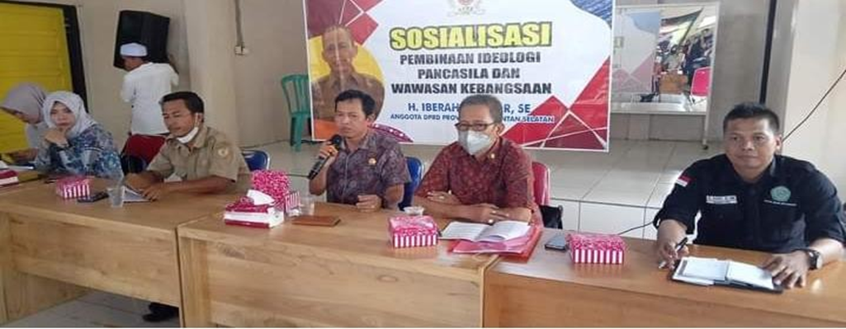

**Figure 1. National Insight Socialization Activities in Aluan Village, HST Regency**

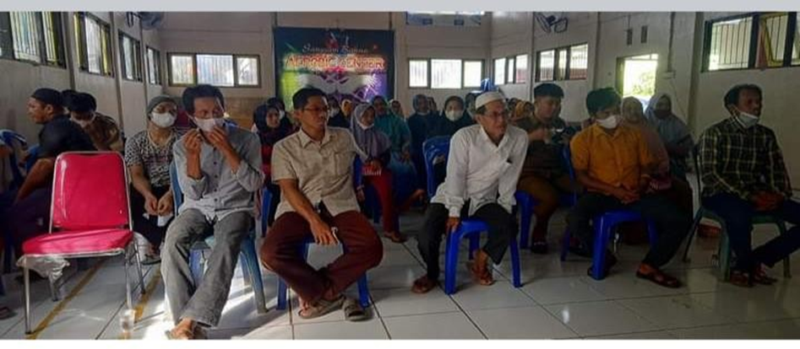

**Figure 2. The People of Aluan Village Took Part in The Socialization of National Insight**

1. **Conclusions**

The core values of national insight, which manifest in the unity and integrity of the nation, consist of six fundamental dimensions: (1) respect for the dignity and worth of humans as creations of God Almighty; (2) a collective determination to live a free, independent, and united national life; (3) love for the homeland and nation; (4) democracy or popular sovereignty; (5) social solidarity; (6) a just and prosperous society. These values serve as the foundation for fostering a harmonious and progressive national identity.

**Reference**

**Serial/journal article (online with DOI):**

Asshiddiqie, J. (2006). Konstitusi dan Konstitusionalisme Indonesia. Jakarta: Konstitusi Press.

Kaelan. (2013). Pendidikan Pancasila. Yogyakarta: Paradigma.

Sunaryo. (2011). The Overlapping Consensus in the Indonesian Constitution and Its Challenges. Jurnal Konstitusi, 20(3), 358-381. <https://doi.org/10.31078/jk2031>

Winarno, S. (2012). Pendidikan Kewarganegaraan: Membangun Karakter Bangsa. Jakarta: Bumi Aksara.