**From campus to capital market:**

**Empowering future investors at STIE Pancasetia**

**Rifqi Amrulloh** 1* **Fredy Jayen** 2 **Arifia Nurriqli** 3 **Tina Lestari** 4 **Rahmat Hilmi** 5

1,2,3,4,5 Pancasetia College of Economics, Banjarmasin, 70248, South Kalimantan, Indonesia

**Email**

[rifq_juve@yahoo.com](mailto:rifq_juve@yahoo.com) *, [fredy.jayen@gmail.com](mailto:fredy.jayen@gmail.com), [arifianurriqli.40@gmail.com](mailto:arifianurriqli.40@gmail.com), [lestari.tn@gmail.com](mailto:lestari.tn@gmail.com), [rahil.hilmi@gmail.com](mailto:rahil.hilmi@gmail.com)

**Received:** Month, Date, Year (Required) **Revised:**  **Accepted:**

**Abstract**

This community service activity aimed to educate students at STIE Pancasetia Banjarmasin and Banjarbaru on the capital market. The capital market plays a crucial role in connecting companies and institutions seeking funding with investors who are looking to invest their funds. The activity included socialization sessions that covered topics such as the definition, functions, and products of the capital market, including stocks, bonds, mutual funds, and derivatives. The methodology used involved registration, attendance, material presentation, and closing. The results of this activity showed that while the participants gained a basic understanding of the capital market, many still had limited knowledge of its operations. Furthermore, they learned about inflation, investment opportunities in the capital market, and financial institutions associated with it. The conclusions drawn from the activity highlighted the need for further education on capital market transactions and more engagement in practical activities. As for the suggestions, it was recommended that students be motivated to remain consistent in their capital market involvement, gain a deeper understanding of market transactions, and participate in future community service activities organized by research and community service institutions. This program aims to improve financial literacy and capital market awareness among students, equipping them with knowledge crucial for their financial future.

**Keywords:** capital market, financial literacy, community service, investment, education, STIE Pancasetia

**DOI :**

**p-ISSN :**

**e-ISSN :**

**ⓒ Copyright: BDJ Action : Breakthrough Development Journal in Advancing Communities the Innovation & Outreach Network (2025)**

**This is an Open Access article distributed under the terms of the Creative Commons Attribution 4.0 International License. Site Using OJS 3 PKP Optimized.**

1. **Introduction**

The year 2020 marked a particularly difficult period for many individuals around the globe. According to the Directorate General of State Assets Management (DJKN) of Indonesia's Ministry of Finance, the COVID-19 pandemic, officially declared a global health crisis by the World Health Organization (WHO) on March 9, 2020, led to widespread disruptions. Countries implemented lockdowns, large-scale business restrictions, and travel bans to mitigate the spread of the virus. In response, WHO encouraged the global population to practice physical distancing, resulting in a significant shift towards online-based activities across sectors, including business and education. The pandemic’s impact on financial stability was profound, with many individuals facing wage reductions or even termination, which forced them to seek alternative sources of income for survival.

Interestingly, despite economic uncertainty, public data released by PT Kustodian Sentral Efek Indonesia (KSEI) in January 2021 revealed a remarkable increase in the number of capital market investors. From the end of 2018 to the end of 2019, the investor base grew from 1,619,372 to 2,484,354—a 53.41% increase. However, this growth was surpassed in 2020, with the number of investors reaching 3,880,753 by year-end, despite ongoing pandemic-related restrictions. This phenomenon illustrates a shift in public interest toward capital market investment, especially as many real-sector businesses struggled due to limitations such as Indonesia’s large-scale social restrictions (PSBB).

According to the Indonesia Stock Exchange (IDX), the capital market serves as a platform for trading long-term financial instruments such as stocks, bonds, mutual funds, and derivatives. As stipulated in Law No. 8 of 1995 on Capital Markets, the term “capital market” refers to activities related to public offerings, securities trading, and institutions and professions associated with securities. The capital market plays a critical role in national economic development through two primary functions: first, as a means for companies to raise funds from investors for business expansion or working capital; and second, as an avenue for the public to invest in financial instruments.

Over time, capital markets—particularly the stock market—have become not only investment vehicles but also income-generating opportunities. Stocks, known for their high potential returns, have attracted both fundamental and technical investors. However, the significant correction in the Indonesia Composite Index (IHSG) on March 20, 2020, served as a wake-up call for many, especially novice investors, reminding them that stock investment is not without risk.

Financial education, especially capital market literacy, has become increasingly relevant. Financial literacy involves a series of activities designed to enhance individuals’ understanding and access to financial institutions. Capital market education aims to bridge knowledge gaps, as highlighted by the launch of the "Yuk Nabung Saham" campaign on November 12, 2015, by then Vice President Jusuf Kalla. This initiative sought to promote stock investment by reducing the minimum lot size from 500 to 100 shares, allowing individuals to start investing with as little as IDR 100,000.

The capital market consists of various instruments, including stocks (common and preferred), bonds, mutual funds, and derivatives such as options, warrants, and rights. Each instrument offers unique characteristics, risks, and potential returns. The educational value of these instruments is vital for fostering a financially literate society that is capable of making informed investment decisions.

Furthermore, capital market analysis incorporates multiple financial theories, including the Du Pont analysis for fundamental analysis, Time Value of Money, Margin of Safety, Dividend Discount Model, Asymmetric Information, and Efficient Market Hypothesis for valuation, as well as portfolio theory and performance evaluation models such as Sharpe, Treynor, and Jensen Alpha for mutual fund investment assessment. These theories not only form the foundation of capital market education but also evolve in tandem with changing financial dynamics.

This community service project aims to increase awareness and understanding of capital markets, provide education on market instruments, explore investment opportunities, and introduce related financial institutions to the broader public. Through this initiative, we aim to equip participants with the knowledge necessary to make rational and informed financial decisions in the post-pandemic era.

1. **Research Design and Method**

*Target audience*

This community service activity was conducted for students of STIE Pancasetia, both from Campus STIE Pancasetia in Banjarmasin and Banjarbaru, with the aim of providing education on capital markets.

*Method of implementation*

The method implemented in this community service program was socialization, which took place through a series of steps to ensure smooth and effective delivery. First, participants were required to register online. Then, attendance was checked before entering the session room to ensure all participants were present. The core of the activity involved delivering the educational material on capital markets, followed by a closing session to summarize the key points and provide reflections on the learning experience. This structured process was designed to engage the students effectively and ensure their participation throughout the event.

*Location*

The activity was held at STIE Pancasetia Campus, located at Jalan Trikora, Guntung Manggis, Landasan Ulin, Banjarbaru City, South Kalimantan 70721, Indonesia.

1. **Results and Discussion**

The capital market involves activities related to public offerings and the trading of securities, public companies related to the securities they issue, as well as professional institutions associated with securities. It serves as a platform where companies or other institutions (such as the government) in need of funding for business development, expansion, working capital, and other purposes, meet with the public who are willing to invest their funds. To obtain funding, these companies or institutions issue stocks or bonds, and investors fund them by purchasing these instruments in the capital market, either directly or through mutual funds. Therefore, the capital market plays an essential role in a country's economy. In addition to stocks, bonds, and mutual funds, the capital market also trades other forms such as warrants, rights, and other derivative products.

Capital market products can generally be divided into two categories: direct investment products such as stocks and bonds, and indirect investment products such as mutual funds. Over time, these products have evolved, leading to the emergence of derivative products, variations, and hybrid products that combine characteristics of both. The Capital Market Supervision Sector is responsible for managing the system of regulations and supervision in the capital market sector, which is integrated into all activities within the financial services sector.

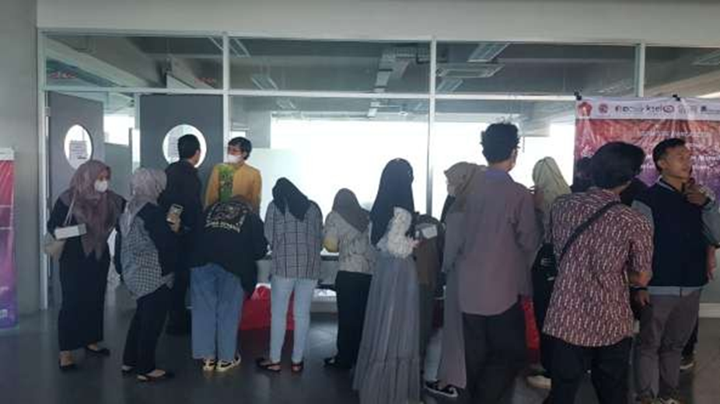

**Figure 1. Participants Were Registering to Take Part in the Activity.**

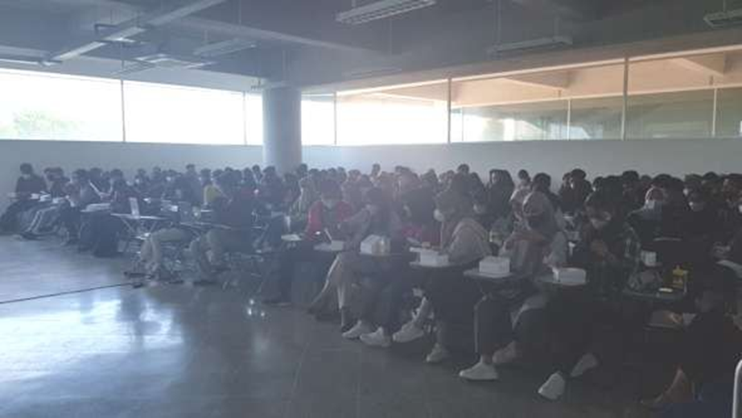

**Figure 2. Participants Were Taking Part in Activities**

In carrying out its functions, the Capital Market Supervision Sector has several key responsibilities: (1) Formulating implementation regulations in the capital market sector; (2) Implementing the Capital Market Crisis Management Protocol; (3) Establishing accounting standards in the capital market sector; (4) Formulating standards, norms, guidelines, criteria, and procedures in the capital market sector; (5) Conducting analysis, development, and supervision of the capital market, including the Islamic Capital Market; (6) Enforcing laws in the capital market sector; (7) Resolving objections raised by parties subject to sanctions by OJK, the Stock Exchange, Clearing and Guaranteeing Institutions, and Custodian and Settlement Institutions; (8) Formulating principles of Investment Management, Transactions, and Securities Institutions, as well as governance for Issuers and Public Companies; (9) Providing training and supervision for entities that obtain business licenses, approvals, or registrations from OJK and other parties in the capital market sector; (10) Issuing written orders, appointing, and/or establishing statutory managers for financial services institutions operating in the capital market to prevent and mitigate consumer, public, and financial sector losses; and (11) Carrying out other tasks assigned by the Board of Commissioners.

1. **Conclusions**

The conclusion from the results of the community service activity is as follows: First, participants gained education about the capital market. However, many participants still had limited understanding of capital market knowledge. Second, the participants learned about inflation. Third, they were introduced to investment opportunities in the capital market. Lastly, participants gained insight into the financial services institutions related to the capital market.

For future community service activities, several suggestions are offered: First, motivate students to remain consistent in their involvement with the capital market. Second, provide deeper understanding of how transactions occur in the capital market. Third, encourage participation in activities organized by the Research and Community Service Institutions to foster further engagement and knowledge.

**Reference**

**Serial/journal article (online with DOI):**

DJKN Kemenkeu. *Aktivitas Pasar Modal Indonesia*. Retrieved from [https://www.djkn.kemenkeu.go.id/kpknl-kupang/baca- artikel/13817/Aktivitas-Pasar-Modal-Indonesia-Di-Era-Pandemi.html](https://www.djkn.kemenkeu.go.id/kpknl-kupang/baca-%20artikel/13817/Aktivitas-Pasar-Modal-Indonesia-Di-Era-Pandemi.html)

IDX. *Belajar Pasar Modal*. Retrieved from [https://www.idx.co.id/investhub/belajar- pasar-modal/](https://www.idx.co.id/investhub/belajar-%20pasar-modal/)

OJK. *Pasar Modal*. Retrieved from [https://www.ojk.go.id/id/kanal/pasar- modal/tentang-pasar-modal/pages/tugas.aspx](https://www.ojk.go.id/id/kanal/pasar-%20modal/tentang-pasar-modal/pages/tugas.aspx)

OJK. *Buku Pasar Modal*. Retrieved from <http://lib.ibs.ac.id/materi/ojk/Buku%203%20Pasar%20Modal.pdf>

Pasar Investasi, Struktur Pasar Modal. Retrieved from <http://www.pasarinvestasi.com/library.php?page=struktur_pasar_modal>

Sahammu. *Pasar Modal*. Retrieved from <https://www.sahamu.com/pasar-modal/>